User Guide Kirby Connect Patient Portal
Patient portal username/password/security questions have been Reset or Created by Health Information Management (Medical Records).
- Locate email sent to you from KirbyConnect.
- Open email and click on the link.
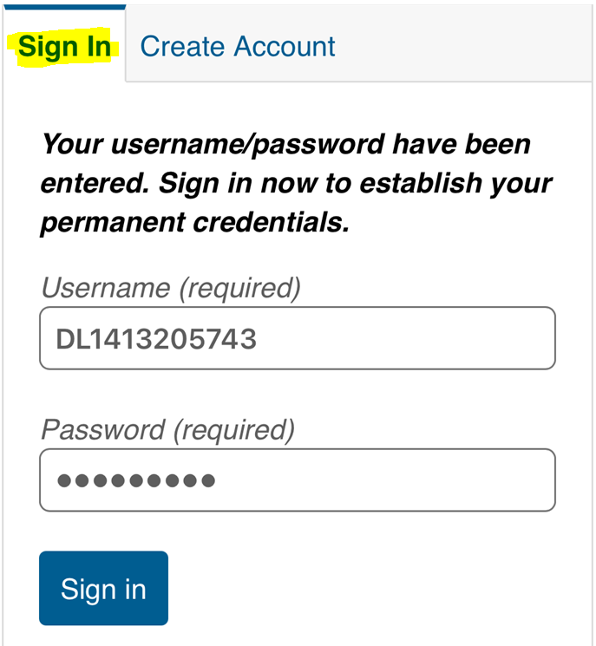
- Stay on the Sign In Tab. Do not click on Create Account Tab. A temporary username and password has already been assigned you (see below). DO NOT CHANGE anything on this screen, click SIGN IN

- The next screen is where you create your own username, password and 3 security questions.

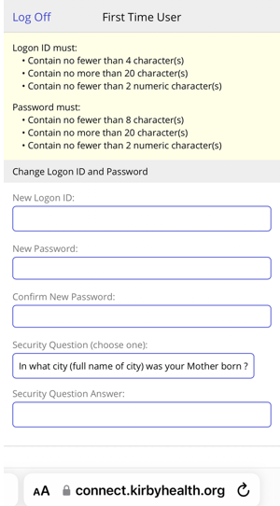
- No special characters or spaces are allowed for the username and password. An email cannot be used as a username as it contains a special character.
- For security questions: click into the question field and select from the drop-down menu. Answers are case sensitive so whatever you put in here, it will need to be exactly the same if you are asked to answer it. Click Save.
- First Time Users will see a user agreement. To move forward, click accept. You will then be directed to the portal.
- IMPORTANT: Please do sign out and login immediately to see if it will work. The software needs time to save the information. Suggest waiting an hour.
- Call HIM/Medical Records if you have any questions or problems getting in at 217-762-1860

